Design and Development of a Wearable Assistive Safety System Using ESP32

TITLE
H.O.P.E: Head level Obstacle detection and Personal Emergency system

AUTHORS
Muhammad Naufal Hakimi Bin Irwan Affandi, Adam Nabil Haniff bin Ruzaimi, Muhamad Iqbal Bin Md Isa, Department of Mechatronics Engineering, International Islamic University Malaysia, Email: nabilhaniff205@gmail.com

ABSTRACT

Wearable assistive technologies have become increasingly important in improving the safety, mobility, and independence of individuals who are visually impaired or physically vulnerable. This paper presents the design and development of a wearable assistive safety system consisting of a smart vest and a bracelet unit, both based on ESP32 microcontrollers. The proposed system integrates AI-based face authentication, eye-level obstacle detection, fall detection, wireless haptic feedback, and real-time emergency notification via Telegram. Face recognition is implemented as an unlocking mechanism to ensure that the system operates only when an authorized user is detected, thereby preventing misuse and theft. An ultrasonic sensor positioned at eye level enables the detection of elevated obstacles such as hanging signboards and tree branches, which are commonly missed by ground-level assistive devices. Fall detection is achieved using inertial sensing and orientation analysis, with emergency alerts automatically sent to pre-registered contacts when a severe fall is detected. Low-latency wireless communication between the vest and bracelet units is implemented using ESP-NOW. Experimental evaluation demonstrates reliable real-time performance and effective assistive feedback, highlighting the suitability of the proposed system for wearable safety applications.

INTRODUCTION

The visually impaired and those prone to accidental falls face significant mobility and security challenges in their daily lives. Most of these individuals encounter hazards related to navigating complex environments, particularly in urban areas where elevated obstacles are common [1]. Conventional mobility aids, such as the standard white cane, are effective for detecting ground-level obstructions but lack the capability to identify "head-level" hazards like hanging signboards, tree branches, or overhead structures. These elevated risks frequently lead to serious facial and head injuries, highlighting a critical gap in current assistive technology [2]. Furthermore, investigations show that user safety is often compromised by a lack of security features; many wearable devices are vulnerable to unauthorized use and lack automated emergency response mechanisms, leaving users stranded if they are unable to manually seek help.

Environmental hazards are further compounded by the limitations of basic detection systems. While traditional canes provide tactile feedback from the floor, they fail to warn against onward or raised objects, which is particularly dangerous in crowded or unfamiliar territories. In addition to physical obstacles, the absence of real-time communication delays the arrival of assistance during critical incidents. Cases have been documented where individuals suffered from falls or sudden medical emergencies but remained unnoticed due to the lack of automatic alert capabilities. Such risks are even more pronounced for the elderly, where a fall or a stroke can occur without the victim having the strength or ability to trigger a manual alarm [3].

To tackle these multifaceted problems, this project proposes a wearable assistive safety system designed with intelligent, multi-sensor integration. The system moves beyond basic obstacle detection by incorporating several advanced features: AI-based unlocking for secure authentication, eye-level obstacle detection using ultrasonic sensors, and an automated fall detection algorithm. Built upon the ESP32 microcontroller, the device leverages low power consumption and wireless P2P protocols like ESP-NOW to ensure reliable, remote connectivity. The system is designed to provide intuitive haptic feedback to the user while simultaneously notifying pre-registered caregivers of the user’s location during an emergency. All components, including the microcontroller, sensors, and vibration motors, are selected to ensure the device is lightweight, precise, and cost-effective.

Advanced Assistive Technology has gained significant traction in recent years, shifting from simple mechanical tools to multifunctional smart devices. Continuous research into sensor fusion and real-time processing is essential for addressing the specific predicaments of visually impaired users [4].
Table 1 provides a comparison of existing smart assistive systems and how they differ from the proposed wearable solution.

Table 1 Table of comparison

Ref/Year | Title | Advantages | Disadvantages | Comparison with our design
Our Project  2026 | H.O.P.E (Head level Obstacle detection and Personal Emergency system | Head-level detection, AI Face Authentication, Fall detection, and silent haptic bracelet. | Requires managing three wearable nodes, No GPS based tracking.
[5]  2018 | Sunu Band | Wrist-worn sonar; provides 15ft range; haptic feedback. | Range limited to what the wrist points at; lacks fall detection. | Our project uses head-level scanning, which is more natural than pointing at the wrist.
[6]  2020 | WeWALK Smart Cane 2 | AI-powered navigation; ChatGPT integration; audio and haptic feedback. | Relies on smartphone connections for most smart features. | Our system performs autonomous fall detection without needing a mobile app active.
[7]  2020 | Envision Glasses | Visual assistance (Find objects/people); video call to an "Ally". | Expensive; relies heavily on cloud/Wi-Fi for advanced AI. | Our ESP-NOW communication is faster (low-latency) and works offline for safety.
[8]  2022 | Lighthouse TAMI | Discreet glasses design; head-level detection via haptic vibration. | Minimal features: lacks fall detection and automated emergency alerts. | Our project offers a multi-sensor array (IMU + Husky Lens) for holistic safety.

METHODOLOGY

Project Development
Overall, a block diagram is an overview of the entire system such that the connection between input, output, and microcontroller can be explained. The project on H.O.P.E. has 2 circuits which are categorized as Vest unit and Bracelet unit. The block diagram of the Vest unit is displayed in Fig. 1 with a combined block diagram of System 1 (Face Authentication System), System 2 (Obstacle Detection System), and System 3 (Falling Detection System). The following single diagram demonstrates the collaboration of the three mechanisms that secure the efficiency of the project in general. While Fig. 2 will show the Bracelet unit integrated with Esp 32 (slave) and vibrator module. Fig. 3 indicates the flow chart of the system that represents the work principle of H.O.P.E.

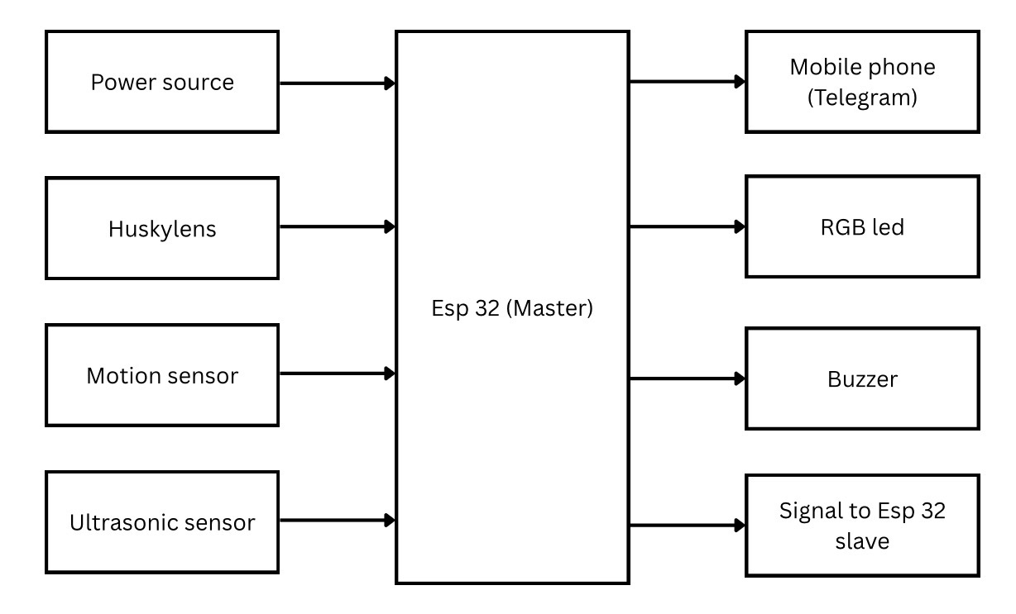
Fig. 1 Block diagram of Vest Unit

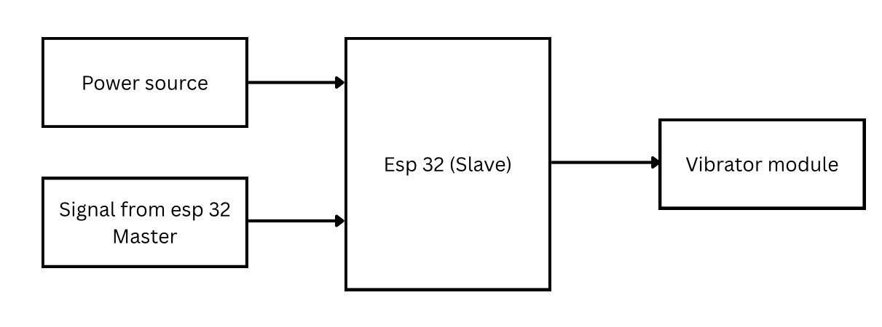

Fig. 2 Block diagram of Bracelet Unit

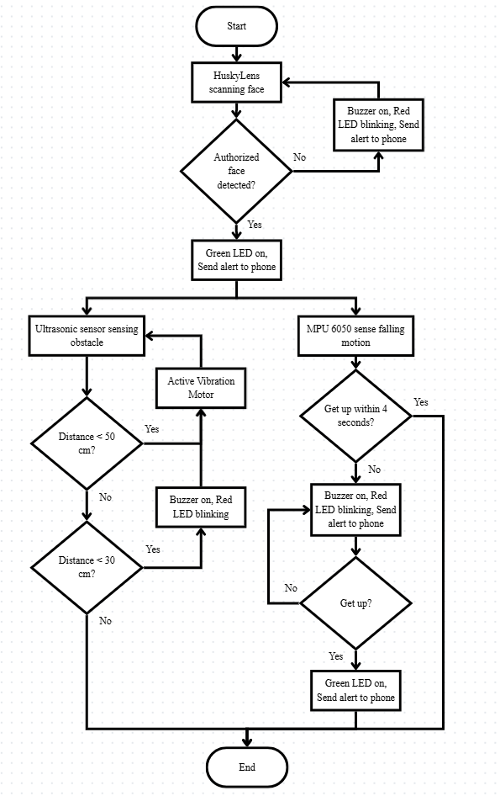
Fig. 3 The flow chart explains all the work principles for the H.O.P.E project.

Schematic Diagram and Prototype Setup

Fig. 4a illustrates the circuit diagram of the Vest Unit (Master Hub), which serves as the central processing unit powered by a Li-Po battery. This hub integrates a HuskyLens AI camera for face authentication, an MPU6050 IMU for fall detection, and an HC-SR04 ultrasonic sensor attached to a sunglass to detect head-level obstacles. To provide immediate local feedback, the system includes a buzzer for audible emergency alerts and an RGB LED to visually signal the system's status. In the meantime, Fig. 4b exhibits the overall system configuration where the master hub communicates wirelessly via the ESP-NOW protocol to the Haptic Bracelet Unit (Slave). As shown in the Bracelet Unit circuit diagram, an ESP32-WROVER triggers a vibration motor to provide real-time tactile feedback to the user upon obstacle detection or emergency events.

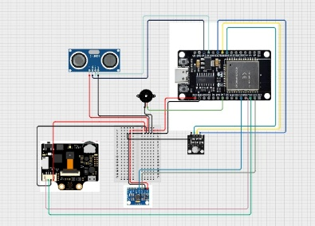
Fig. 4a Electrical Design of Vest Unit (Master Hub)
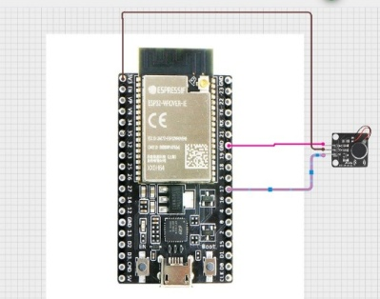
Fig. 4b Electrical Design of Bracelet Unit (Slave)
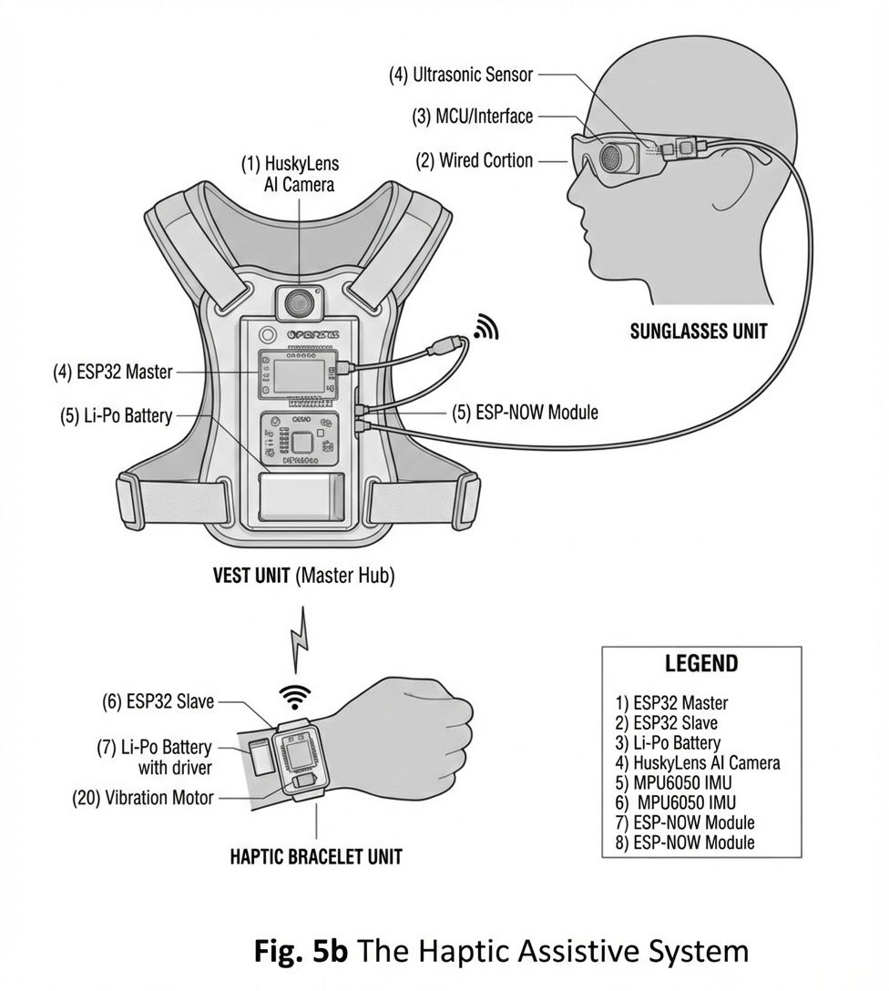
Fig. 5 The H.O.P.E system

RESULT AND DISCUSSION

System 1 (Face Authentication System) Analysis
The Face Authentication System serves as the primary barrier, ensuring that the wearable device is operated by the verified user only. Through an AI-based camera unit (HuskyLens), the system continuously monitors for specific pre-registered identities to maintain a secure state. Figure 6a shows that when an authorized face is detected, the system provides an immediate positive response by activating a green LED and notifying the caregiver via Telegram that the vest has been successfully unlocked, as shown in Figure 6b. Meanwhile, Figure 7a indicates that if an imposter is detected, the system activates an emergency mode where it will trigger a synchronized red LED blinking and buzzer alarm. To prevent theft or misuse, this unauthorized state also generates high-alert emergency notifications, as shown in Figure 7b, to the caregiver every few seconds, ensuring that the device remains safe even if taken by any stranger.
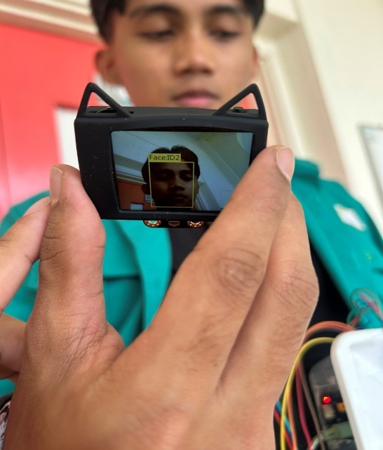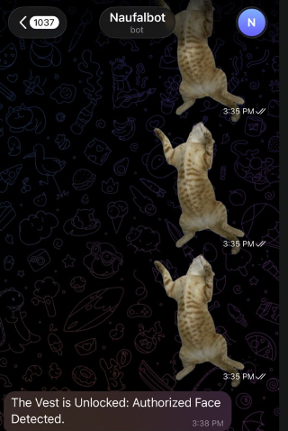
Fig. 6a Authorized face detected Fig. 6b Notification to the caregiver

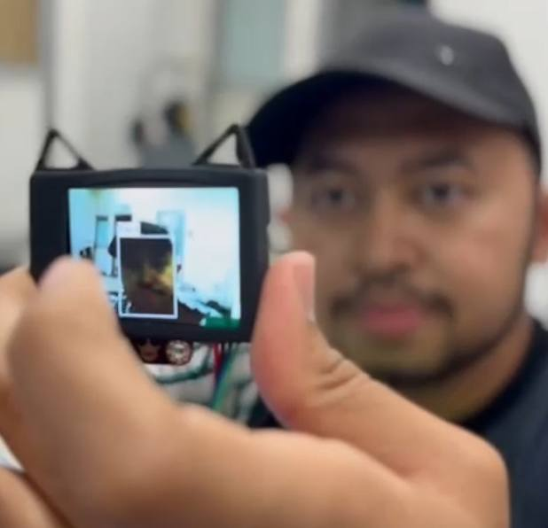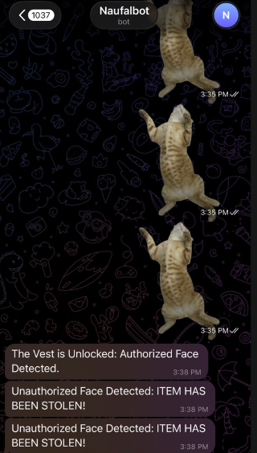
Fig. 7a Unauthorized face detected Fig. 7b Emergency notification to the caregiver

System 2 (Obstacle Detection System) Analysis
The Obstacle Detection System is designed to detect the danger of head-level hazards, like low-hanging branches or signboards, where any standard mobility aids like a cane often fail to identify because they only detect ground-level obstacles. The system utilizes an ultrasonic sensor to create a pre-calculated danger zone that provides the user with intuitive spatial awareness. Studies report that visually impaired pedestrians typically walk at reduced speeds, ranging from approximately 0.6–1.0 m/s. Based on an average walking speed of 0.8 m/s, the selected detection ranges were designed to provide sufficient reaction time. A distance of 50 cm offers roughly 0.6 s for early awareness, while distances below 25 cm indicate a critical zone requiring immediate response. Figure 8a shows that within a moderate range of 25 to 50 cm, the system provides subtle haptic feedback through a pulsed vibration from a vibrator module on the bracelet, as indicated in Figure 8b, giving the user a heads-up to detect nearby objects without drawing external attention. Figure 9a shows that if the distance is less than 25 cm, the system will transition into an emergency alert state, where it will provide a continuous vibration from the bracelet on the wrist, as shown in Figure 9b, while activating the vest's buzzer, and the red LED will start blinking, as shown in Figure 9c, to signal an immediate obstacle. Table 2 will show the differences in distance sense by ultrasonic sensor while Table 3 shows the intensity of vibration for each distance. Both of these unit configurations rely on low-latency wireless communication to ensure that tactile alerts are delivered on time, which is important for safe navigation in urban environments.
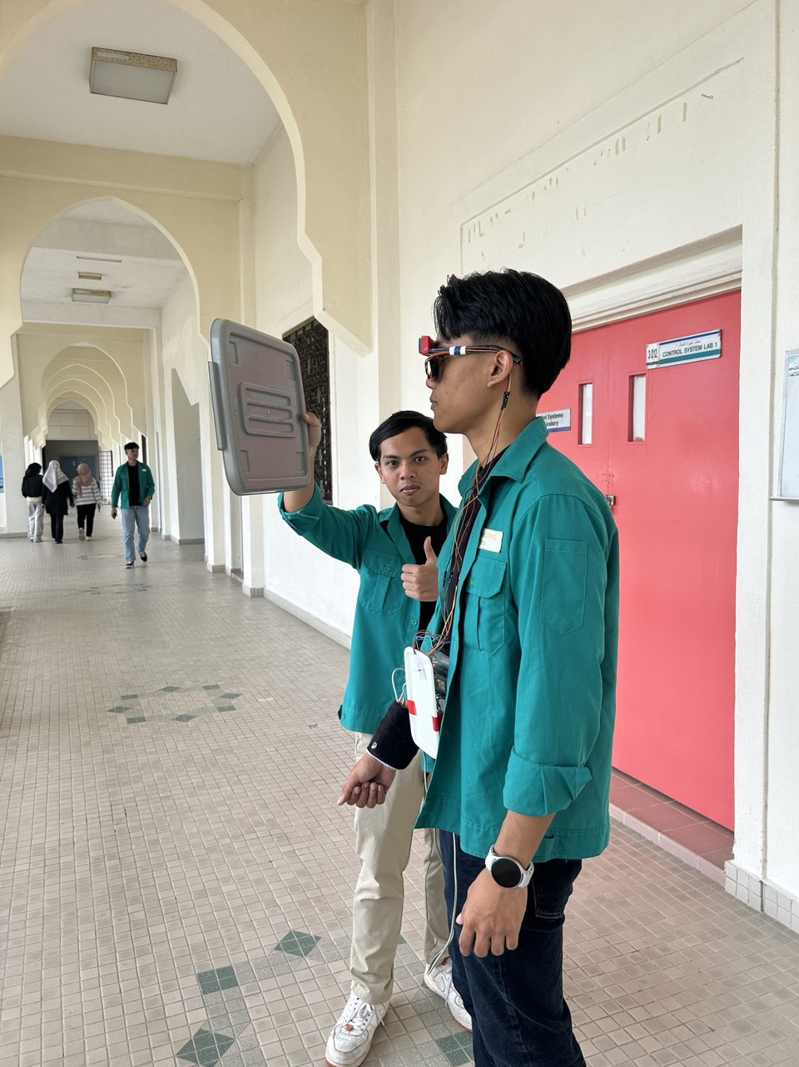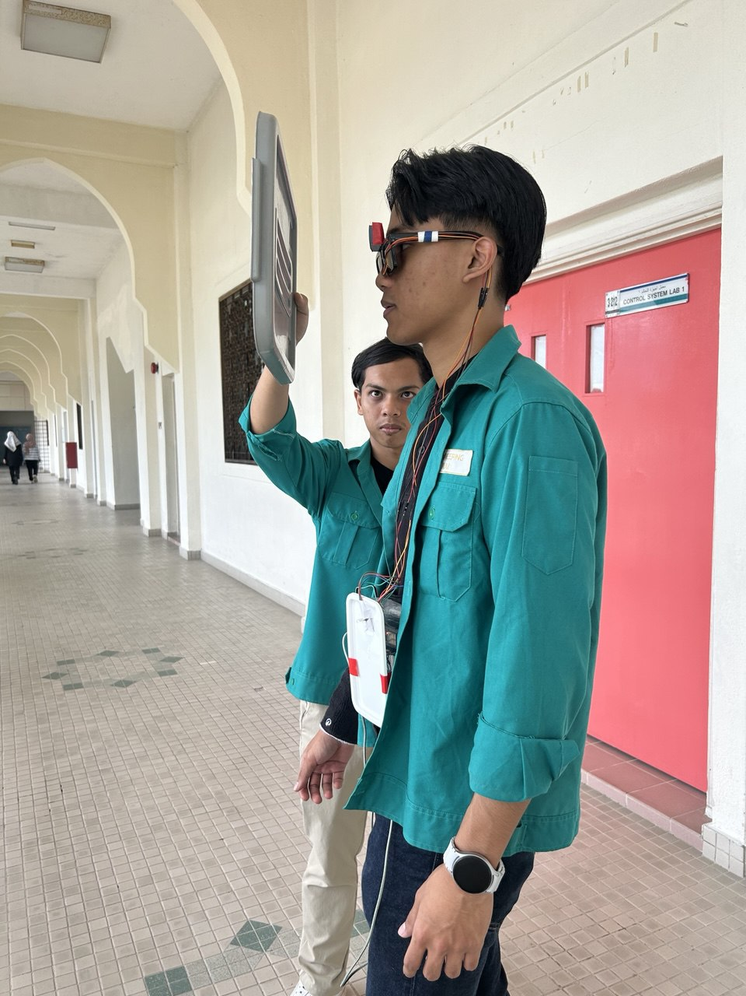
Fig. 8a Sensing obstacle on a range less than 50 cm Fig. 9a Sensing obstacle on a range less than 30 cm

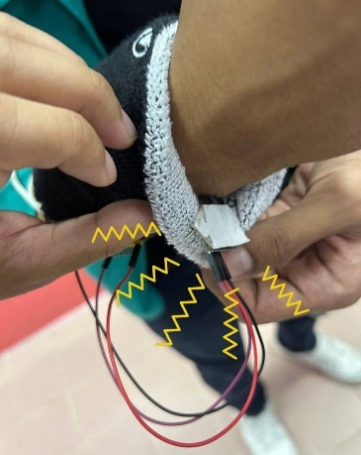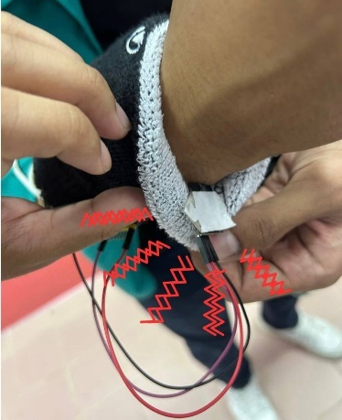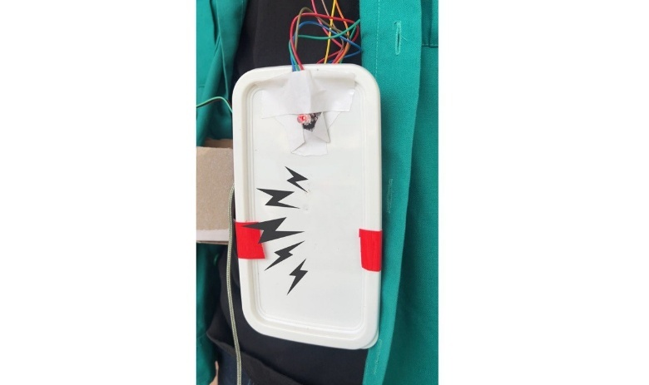
Fig. 8b Haptic feedback Fig. 9b Continuous vibration Fig. 9c Vest alarm triggered
through pulse vibration (Buzzer and red blinking red)

The progress of assistive devices for blind people continues to be an important area of mobility and independence. The classic white cane is essential for finding obstacles at ground level, but it is unable to detect objects above the waist or give contextual information about the environment [1].

Table 2 Figures of testing
55 cm | 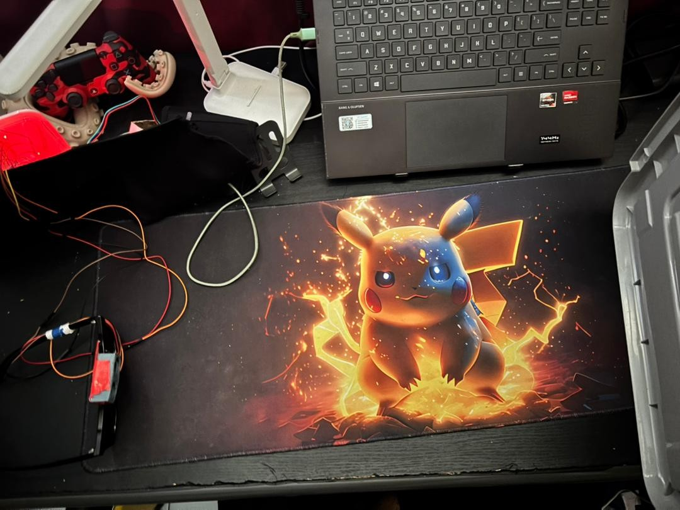  55 cm
40 cm | 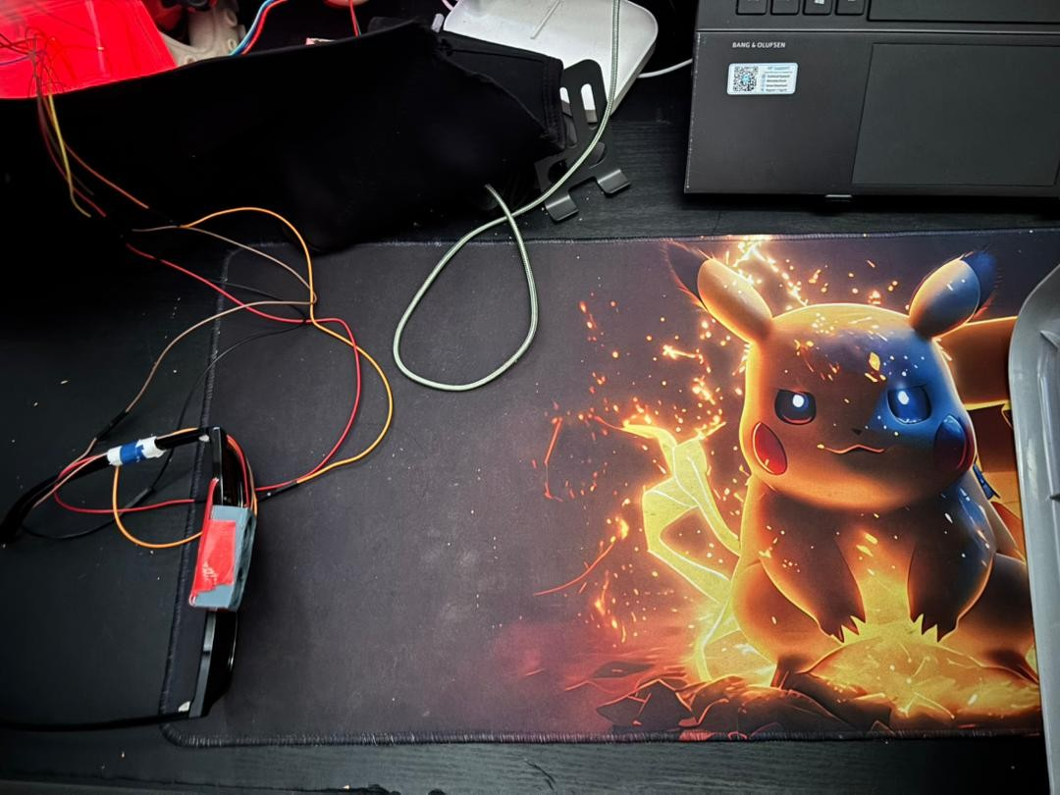  40 cm
25 cm | 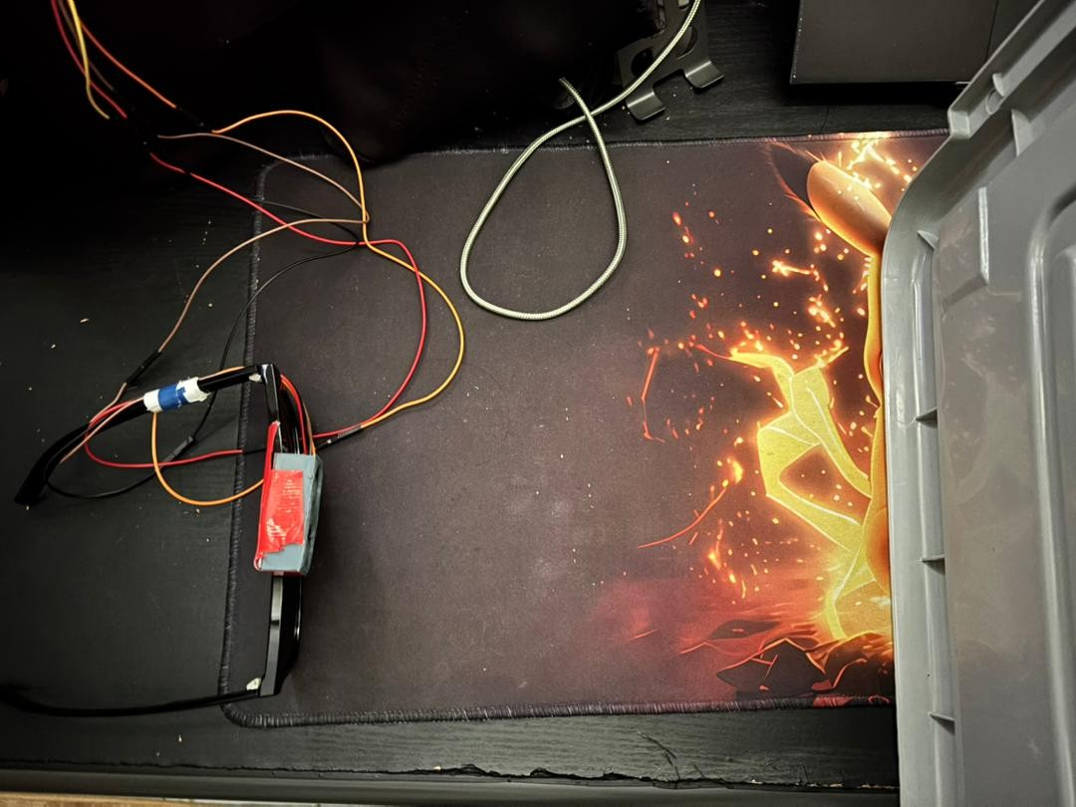  25 cm

Table 3 Results of each distance
Distance from Obstacle (Cm) | Figures of Testing | Observation
>50 | 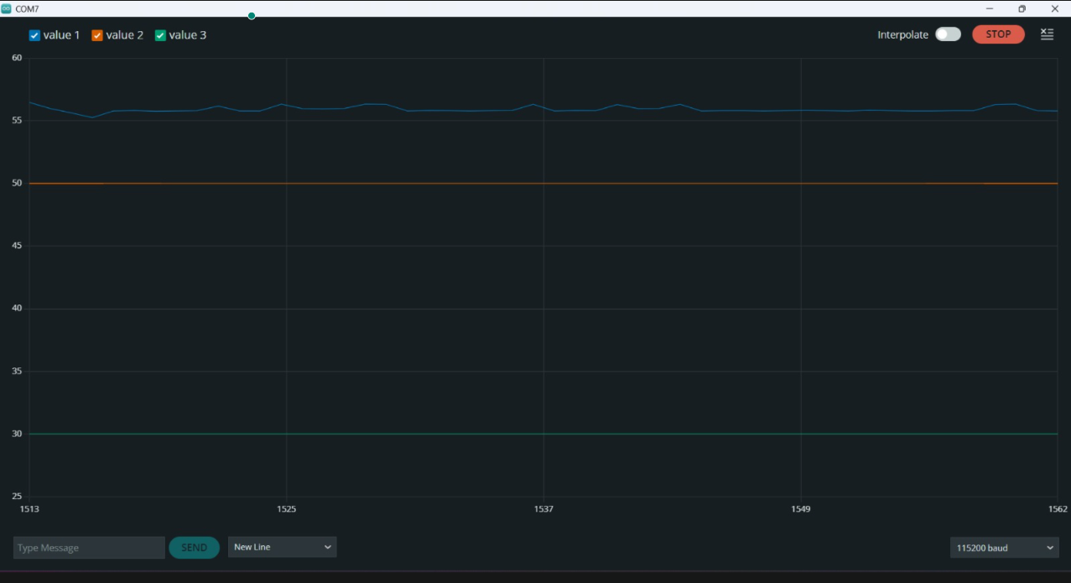 | No vibration, buzzer inactive, red LED off. No obstacle detected.
<50 | 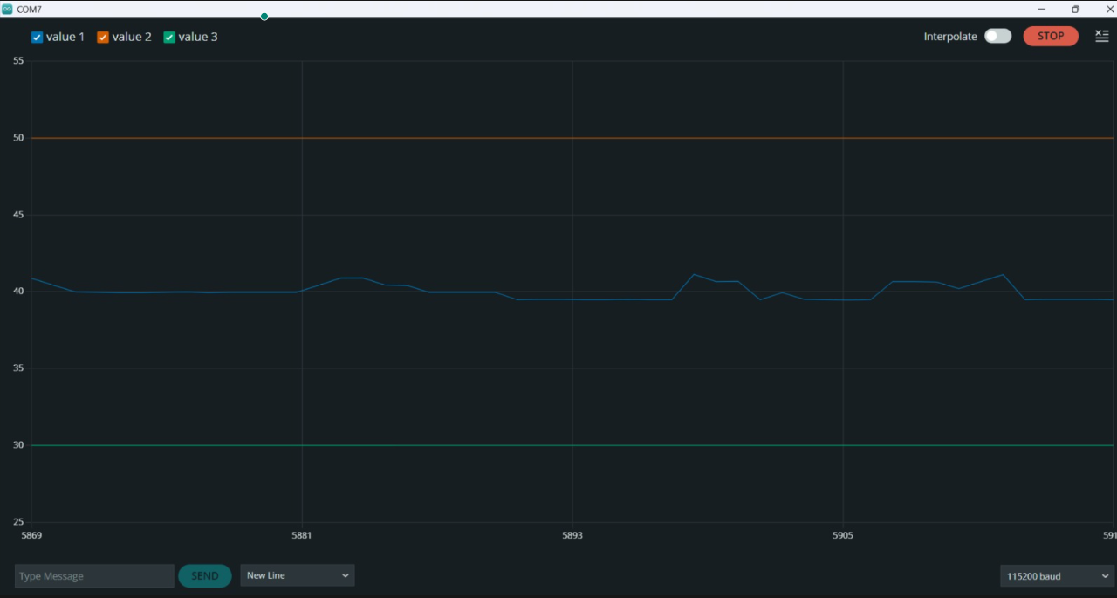 | Subtle vibration, buzzer inactive, red LED off. Obstacle detected but at a safe distance.
<30 | 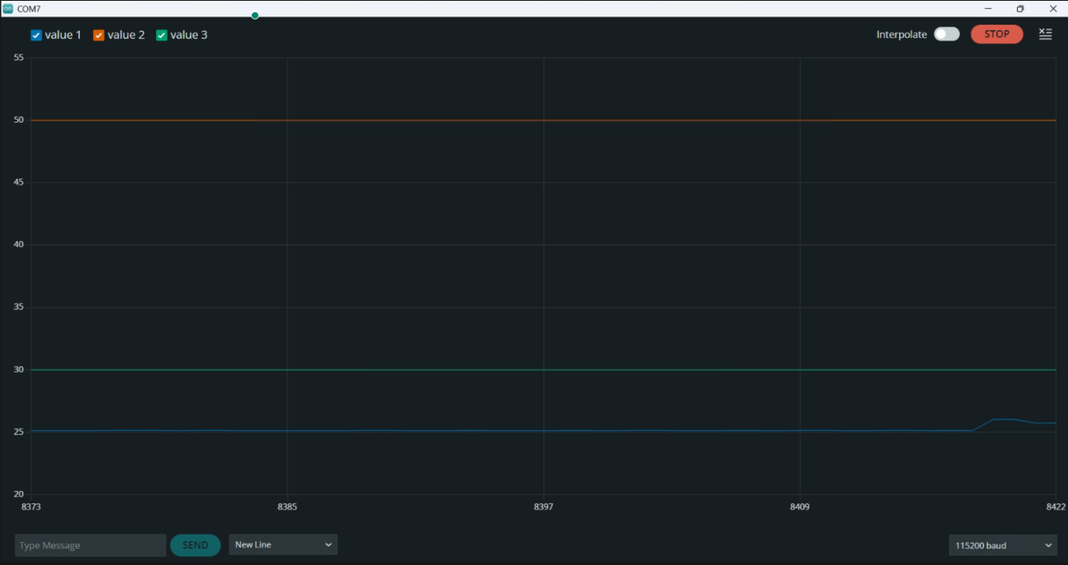 | Continuous vibration detected, buzzer activated, red LED blinking. Obstacle detected ahead; immediate avoidance action required.

Legend: Red line - Threshold (50cm), Green line - Threshold (30cm), Blue line - Ultrasonic detected distance

System 3 (Falling Detection System) Analysis
The Fall Detection System is an essential piece of emergency response equipment for users who are either physically compromised or have impaired stability. Using inertial measurement units (IMU), the system tracks body orientation by computing the pitch and roll of the user’s torso from bottom to top. When the tilt angle is higher than a certain safety threshold, a fall event is automatically detected, which means that the user is no longer in an upright position. To minimize false alarms triggered by ordinary activities such as sitting down too fast, the system applies to a very short confirmation window. If the user does not stand up within an allocated time, which is 4 seconds, an emergency procedure is initiated automatically, where the vest's buzzer will alarm, the red LED will blink to catch the surrounding attention, as shown in Figure 10a, and a distress signal will be sent to the pre-registered caregiver's contacts via Telegram, as shown in Figure 10b. In addition, the system can detect the recovery once the user has successfully stood up from a fall, as indicated in Figure 11, which shows that a second notification is sent to caregivers informing them that the user is fine.
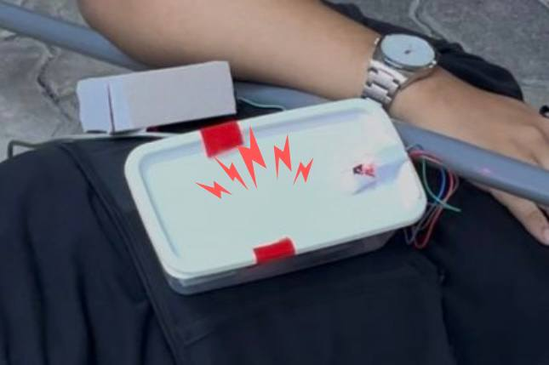
Fig. 10a Vest alarm triggered (Buzzer and red blinking red)

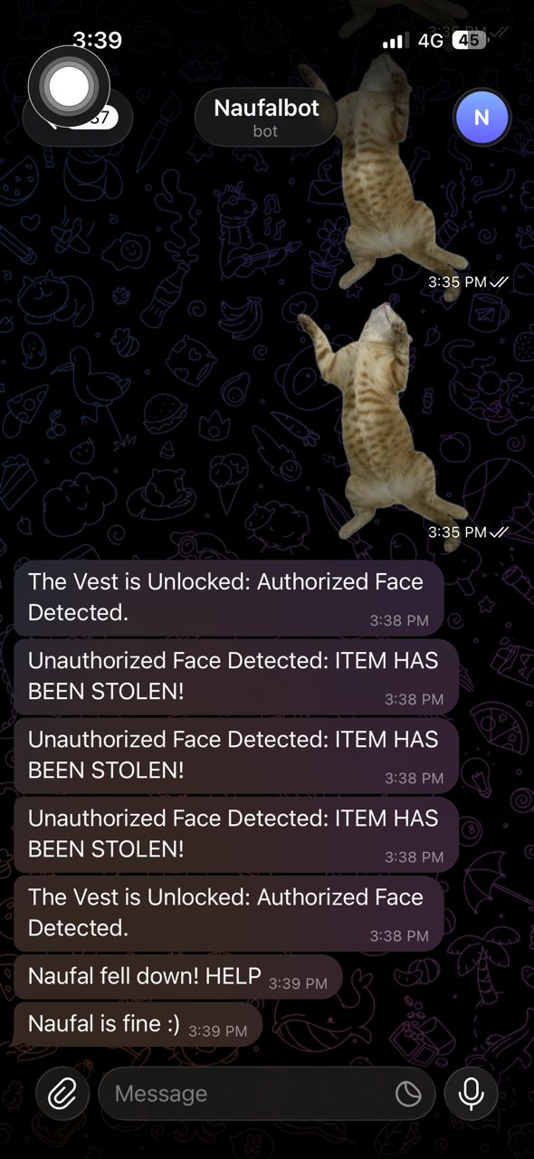
Fig. 10b Distress signal receives by caregivers contact via telegram


Fig. 11 Notification indicate that the user is fine

Vibration Analysis for System 2
In this study, vibration feedback was evaluated to verify the effectiveness of the proposed two-phase obstacle warning strategy implemented in the wristband module. A mobile vibration measurement application, as shown in Fig. 12, was used to observe and compare vibration patterns generated by the wristband during different proximity conditions. The mobile phone was securely fastened near the vibration motor housing of the wristband to ensure stable and consistent measurement, as illustrated in Fig. 13. The application provided real-time vibration graphs and recorded peak and mean vibration values for analysis.
The vibration motor was controlled by a slave ESP32 via ESP-NOW communication. Based on the ultrasonic distance measured by the master ESP32 mounted on the vest, two vibration phases were implemented. In Phase 1, when an obstacle was detected at a distance less than 50 cm, the vibration motor operated in a pulsed mode with a fixed tempo, providing an early heads-up alert to the user. In Phase 2, when the obstacle distance was less than 30 cm, the vibration motor was activated continuously, indicating immediate proximity and requiring urgent user response.
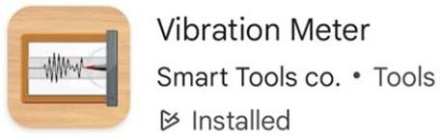
Fig. 12 Vibration Meter Apps

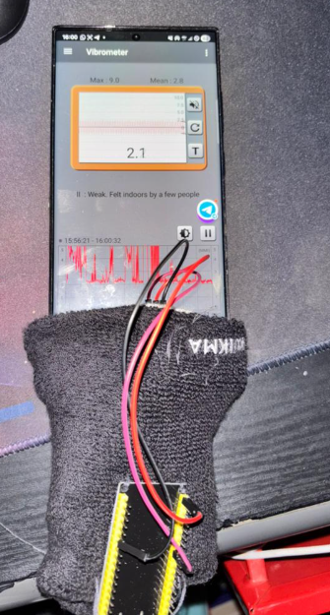
Fig. 13 Mobile Phone Placement inside wristband for Vibration Measurement
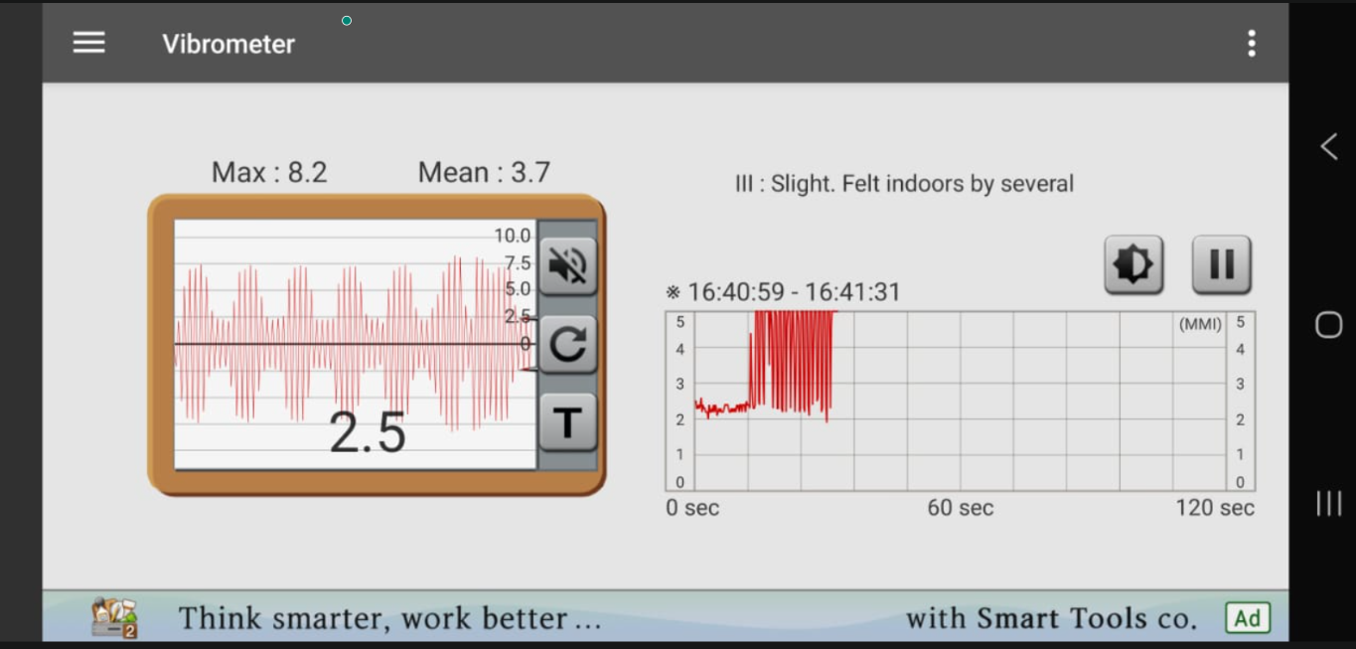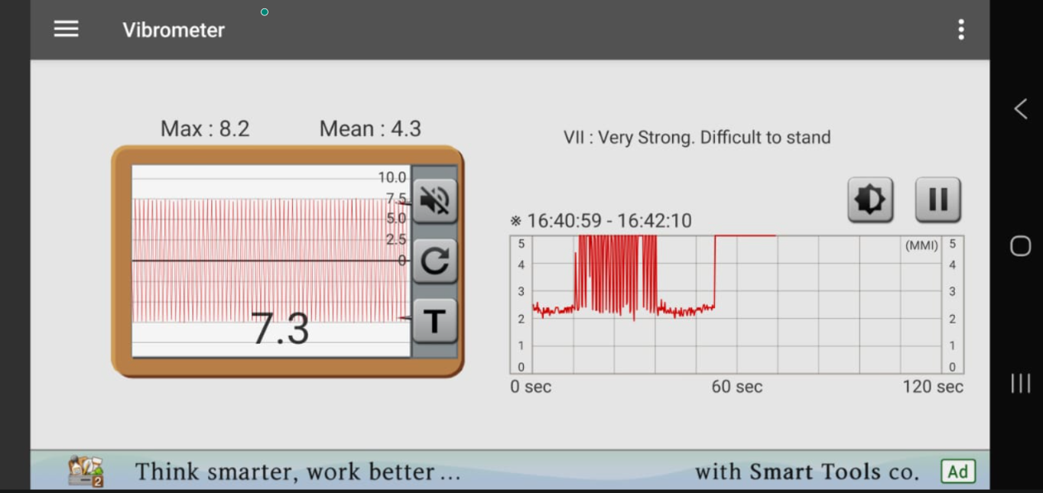
(a) Measured Vibration Response for Phase 1 (b) Measured Vibration Response for Phase 2 (Pulsed Warning Mode) (Continuous Warning Mode)
Fig. 14 Result Vibration
The vibration responses for Phase 1 and Phase 2 are shown in Fig. 14(a) and Fig. 14(b), respectively. Phase 1 produced periodic vibration peaks corresponding to the pulsed warning mode, providing early tactile awareness when the obstacle was within the 30–50 cm range. In contrast, Phase 2 generated a continuous vibration signal when the distance fell below 30 cm, indicating immediate proximity and requiring urgent user response.
Overall, both vibration modes remained clearly perceptible yet comfortable, and the distinct pulsed and continuous patterns effectively conveyed different levels of obstacle proximity. This confirms that the wristband-based vibration feedback is intuitive, responsive, and suitable for real-time assistive navigation.

CONCLUSION
In conclusion, the H.O.P.E. (Head level Obstacle detection and Personal Emergency) system development brings about a good solution to the mobility and safety issues for visually impaired people. By combining multi-sensor hardware with a dual-unit wearable architecture, the project aims to be much more than a traditional assistive instrument, bringing a holistic security and navigation answers. The AI-based face authentication protects the device from being used and stolen by unauthorized users, and the eye-level ultrasonic sensing can accurately detect upper threats that are missed by traditional ground-level tools.
Additionally, the real-time fall detection, instant Telegram message alert and other automated emergency procedures built into the system lessen response times during life-threatening situations. Utilizing the low-latency ESP-NOW protocol for wireless communication between the vest and bracelet modules, haptic feedback is reliable and instantaneous, making the warning system discreet and efficient. On the whole, the H.O.P.E system presents a strong mechatronics and IoT-based solution, which is not only lightweight and cost-efficient but also intelligent, thereby allowing the user a higher degree of independence as well as physical safety.

Acknowledgement
The authors would like to thank the Mechatronics System Integrations laboratory staff for providing the necessary components and technical support for this project.

Conflict of Interest
Authors declare that there is no conflict of interest regarding the publication of the paper.

Author Contribution
The author attests to having sole responsibility for the following: planning and designing the study, data, collection, analysis and interpretation of the outcomes, and paper writing.

REFERENCES
- El-taher, F. E.-Z., Taha, A., Courtney, J., & McKeever, S. (2021). A systematic review of urban navigation systems for visually impaired people. Sensors, 21(9), 3103. https://doi.org/10.3390/s21093103
- Panazan, C.-E., & Dulf, E.-H. (2024). Intelligent Cane for Assisting the Visually Impaired. Technologies, 12(6), 75. https://doi.org/10.3390/technologies12060075
- Karar, M. E., Shehata, H. I., & Reyad, O. (2022). A survey of IoT-based fall detection for aiding elderly care: Sensors, methods, challenges and future trends. Applied Sciences, 12(7), 3276. https://doi.org/10.3390/app12073276
- Cheraghpour Samavati, F., & Rahimi Ghasem Abadi, A. (2025). Assistive technologies for the visually impaired: A review. Cureus Journal of Computer Science, 2(1), es44389-025-06891-1. https://doi.org/10.7759/s44389-025-06891-1
- VisionAid Technologies. (n.d.). Sunu Band premium - Sonar smart-band. https://www.visionaid.co.uk/sunu-band-premium
- WeWALK. (n.d.). Smart Cane 2: AI-powered navigation. https://wewalk.io/en/
- Envision AI. (n.d.). Envision Glasses: AI-powered wearable technology. https://www.letsenvision.com/
- Lighthouse Tech. (n.d.). TAMI: Fashionable smart eyewear for the blind. https://www.lighthousetech.ch/

